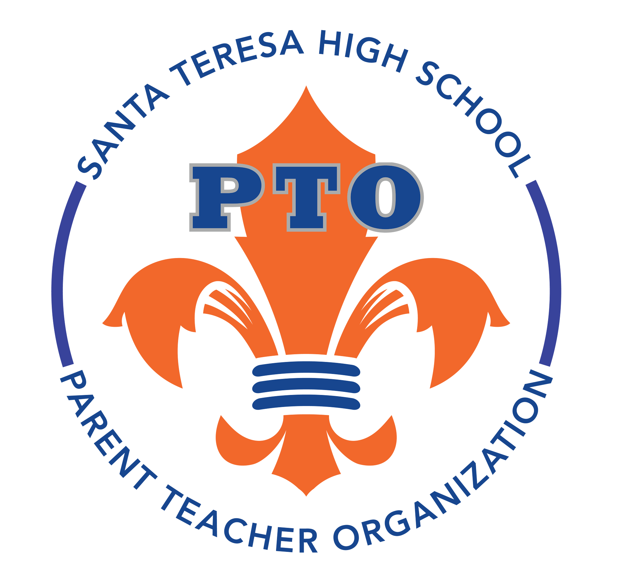
Monthly PTO General Meeting Minutes

1. Meeting called to order at 6:32 pm by Angellina Duran
Date: September 9th, 2026
Location: Santa Teresa High School Library
Board Members Present: Angellina Duran, Brandi Childress, Erika Amin, Kathy Kirtland, and Trudi Konzem
2. Welcome & Introductions (Angellina, Brandi, Erika, Kathy, and Trudi)
- The 2026–2027 PTO Board members introduced themselves.
3. Fundraising & Merchandising (Angellina)
- School Gear: The board decided to offer collared shirts and hats, with a potentially small batch of sweatsuits to test demand. Also, to investigate other colors like baby blue and pink. Specifically pink for October (that is breast awareness month.)
- Corporate Matching: Parents are encouraged to check for corporate matching programs at their workplaces to increase donations.
4. Fundraising & Events (Brandi)
- Restaurant Nights:
  - Las Conzuela’s: Wednesday, September 16th (Mexican Independence Day), from 9 a.m. to 8 p.m.; 20% of proceeds go to the school.
  - Bibo's Pizza & Pasta: Tuesday, September 22nd, 3 p.m. to 9 p.m.; 20% of proceeds go to the school.
4. School Updates (My Nguyen, Associate Principal of Educational Development)
  - AP Tests: Now on sale with a priority deadline of October 30th; late fees of $40 apply after this date.
  - SAT: School-wide testing for juniors is scheduled for March 31st.
  - Civic Seal of Engagement: An optional program where students can earn a seal on their diploma for independent community service projects.
  - Other Initiatives: The school is collecting insurance information for the California Youth Behavioral Health Initiation (CYBHI) to provide no-cost health services.
7. Parent Advocacy & Information (Trevor & Vicki)
- Concerns about SAT testing were discussed with Ms. Nguyen, who will share the information with him and other parents.
- Some questions were discussed regarding volunteering for certain sports that Santa Teresa Athletic Booster Club (STABC) and discussed that it is separate and those funds go towards specific sports.
- A table will be set up at the College & Career night on Wednesday, September 16th at Independence High School for Virtual Health for jobs in the medical field. There will be information regarding the program costing $300 and 18 years or older can get a certificate as a Medical Assistant, Surgical Tech, etc.
Treasurer’s Report & Budget (Erika)
- Current Balance: Ending cash balance as of August was $27,525.07.
- Year-to-Date Performance: Revenue is significantly lower than expenditure, resulting in a negative balance of approximately $2,300 for the current period.
- Recent Expenses: Costs include a Canva yearly subscription ($119.99), Square fees ($5.88), and staff appreciation events.
8. Business Board
- Teacher Grants: The board will establish a clear application window and deadline (potentially October 1st) to review and allocate funds for classroom needs.
- Merchandising Strategy: Gear will be promoted via social media and “walking models” rather than tables at games.
9. Action Items
- Angellina: Get approval from Mr. Chau for the holiday event ideas and share details online once approved. Order a batch of sweatsuits for ST gear and monitor sales before ordering. Look into other colors (pink).
- Brandi: Put out a call for teacher grant applications and set a deadline (suggested October 16th) for submission. Confirm with Las Cazuelas if alcohol sales are included in the fundraiser proceeds and set up A-frames. Organize shifts for volunteers to sit at Las Cazuelas next Wednesday to help track fundraiser participants.
- My Nguyen: Provide information and details about the Civic Seal of Engagement to interested students/parents. Forward the parent’s question about allowing other grade levels to take the SAT during the school-wide testing day to the district.
- Board: Promote PTO’s social media accounts (Instagram and Facebook) and encourage parent involvement.
- Board: Participate in the upcoming restaurant fundraisers at Las Cazuelas (Sept. 16th) and Bibo’s (Sept. 22nd) to support the school.
10. Adjournment
Meeting adjourned at 7:10 p.m.
11. Next Meeting
Date: October 14th, 2026
Time: 6:30 pm
Location: Santa Teresa High School Library
Respectfully submitted,
Kathy Kirtland
PTO Secretary

